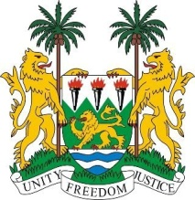
SIERRA LEONE

26th Session of the Universal Periodic Review

ICELAND

STATEMENT BY SIERRA LEONE

1 November 2016

Mr President,

Sierra Leone welcomes the Iceland delegation and thanks them for presentation today.

My delegation is pleased to note that since its last review, Iceland has sought to implement most of the recommendations it accepted during its last review.

We note with interest the government’s establishment of a national action plan against the trafficking in persons (2013 -2016) which is aimed at effectively combatting the trafficking human beings nationally while also working with regional partners.

It is similarly noteworthy that Iceland has an active civil society and secondly, that the government has issued a standing invitation to all special procedures mandate holders.

Sierra Leone would like to encourage the government to increase access to justice for women who are victims of sexual and domestic violence.

Recommendations:

- Accelerate efforts to ratify the ICPPED and implement into national law, the CRPD and withdraw its reservations to the ICCPR.
- Submit its overdue reports to the relevant treaty body mechanisms.
- Implement an action plan on domestic violence and sexual violence against women, including those immigrants and those from minority groups.

Sierra Leone wishes Iceland a successful completion of its national review process.

Thank you, Mr President.

